***Baby store***

Database class project 2022/2023

|  |  |  |  |  |
| --- | --- | --- | --- | --- |
| Student Name in English | Student Name in Arabic | Student ID | Section | Work percentage |
| Leena Dweikat | لينا دويكات | 11923718 | Mon-Wed 9:30-11 | 50% |
| Nancy Sawalmeh | نانسي سوالمه | 12029645 | Mon-Wed 9:30-11 | 50% |
|  |  |  |  |  |

Date/time

---------------------------------------------This section is intended for the Instructor---------------------------------------

|  |  |
| --- | --- |
| **Topic** | **Mark** |
| Project Requirements and Modeling |  |
| Correctness of Database mapping |  |
| Functional Dependency and Normalization |  |
| Project Tools |  |
| Project Discussion |  |
| Project Completeness |  |
| Project Output Results or reporting (JasperReport, charts, graphs, etc.) |  |
| Project Administration and Management |  |
| Project Report |  |
| Project Idea |  |
| Project Complexity |  |
| Team work |  |
|  |  |
|  |  |
|  |  |

Table of content :

Abstract:.......................................................................................................................................................3 Introduction:.................................................................................................................................................3 Project requirements:...................................................................................................................................4 Mapping and UML:.......................................................................................................................................5 Functional Dependency:..............................................................................................................................6 Normalization process: ...............................................................................................................................7 GUI:..............................................................................................................................................................8 Login Interface…..........................................................................................................................................9 Sign up Interface:.........................................................................................................................................9 Manager Interface.....................................................................................................................................10 User interface:...........................................................................................................................................14 Jasper Report............................................................................................................................................17 Tools:........................................................................................................................................................18 Discussion and Conclusion:.....................................................................................................................18

**Abstract**

Baby Store is a store selling children's supplies that contains several interfaces. The first interface is the login interface, from which the login to the store is done by verifying the user or administrator data in the database.

After logging in, you can browse the store and move between destinations.

And to buy the products inside it, you can browse the product interfaces (the clothing interface, the games interface, and the accessories interface), and any product can be added to the cart.

**Introduction**

This application is an online store and consists of two sections, the first section is the user section and the second section is the manager section, in each section several orders are executed, for example in the manager section the product can be added or deleted from the application and the price of each product can be added or changed, A new user can be added, and the manager can view all invoices. The user section consists of several interfaces, where there is an interface for each section of products (clothes, games, and accessories), and at each product there is a button to add to the wallet to purchase products. The application is characterized by clarity and ease of use.

**Project requirements**

Initially, the store works by login, so that each login has a unique username, password and number of logins, the login must verify the number of users who enter the store, as well as verify the number of managers where the store contains a user and consists of A unique user number, username, phone, and e-mail, the user may have several addresses, so that the user can shop for a number of products, and also allows the user to have a number of logins, the user can has a number of bills. The store is controlled by an manager and consists of a unique manager number, manager name, phone and manager age, so that the manager controls a number of products and also the manager has a number of logins. Also in the store there is a product of three types: games , accessories and clothes, each product exactly belongs to these types, so that each product has a unique product number, product name, product image, product price, Each game has a game type and description, as well as each accessory has a accessory type and description, and for Each clothes has a clothes type and description, each product is marketed by a number of users, and must be controlled by one manager as well as for each product has one bill. User purchases are stored in an bill. Each bill contains a unique bill number, bill name, bill date, payment and discount. Each bill contains only one user, and each bill contains a number of products.

**Project UML**

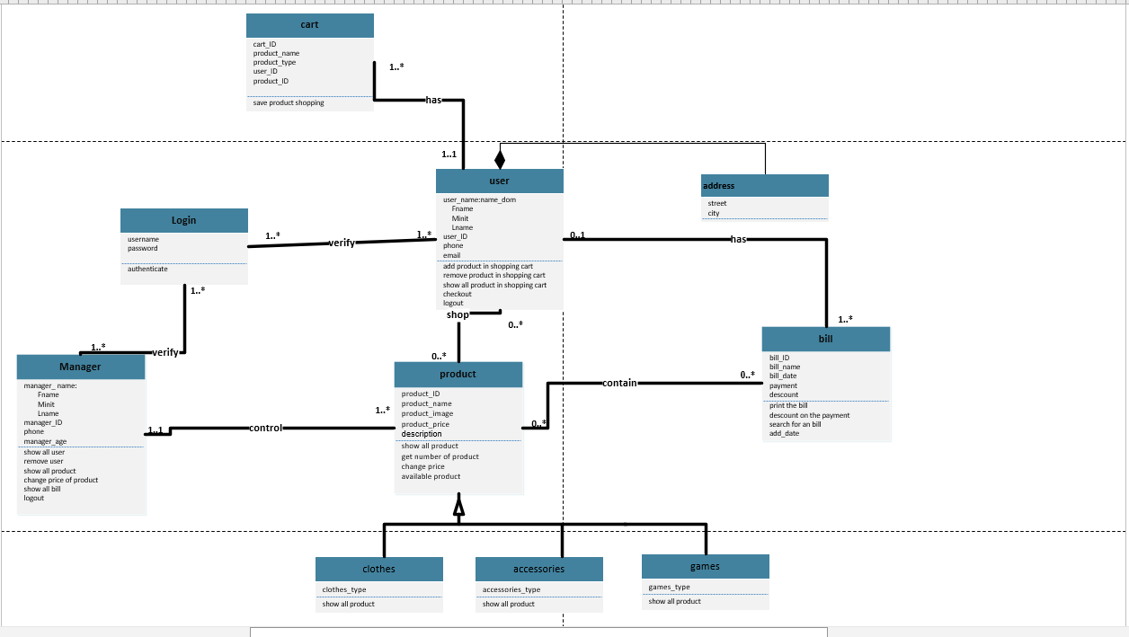

**Project Mapping**

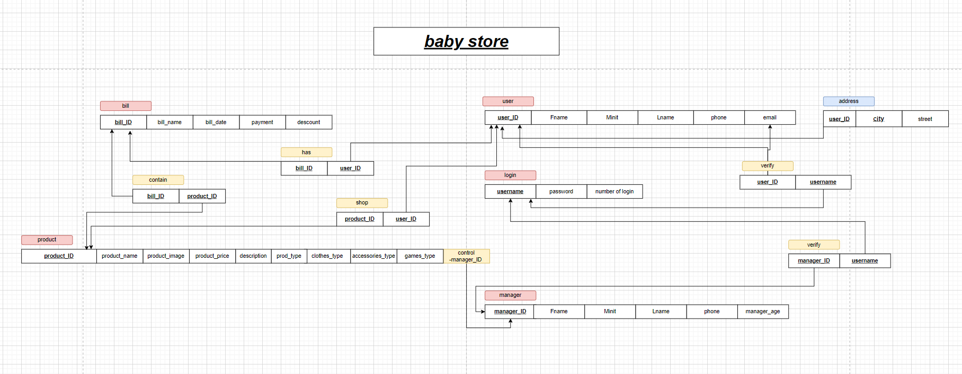

**Functional Dependency**

* ***Userr Table :***

User_id->Fname,Minit,Lname,Phone,Email.

* ***Managerr Table :***

Manager_id->Fname,Minit,Lname,Phone,Age.

* ***Login Table :***

Username->password_login,number_of_login.

* ***Contain Table :***

Product_id->bill_id

* ***Bill Table :***

Bill_id->bill_name,bill_date,payment,discount.

* ***Shop Table :***

Product_id->user_id

* ***Product Table :***

Product_id>product_name,product_image,product_price,

discreption,prod_type,closthes_type,accessories_type,

games_type,conteolmanager_id.

* ***Address Table :***

User_id,city,street.

* ***Has Table :***

User_id->bill_id.

* ***Verifym Table :***

Manager_id->username.

* ***Verifyu Table :***

User_id->username.

* ***Cart Table :***

Cart_id->pro_id,name_pro,price,type_pro,hasuser_id.

Normalization process

***In Userr Table :***

It is (BCNF) from because ever attribute depend on super key (user_id) .

***In Managerr Table :***

It is (BCNF) from because ever attribute depend on super key (manager_id).

***In Login Table :***

It is (BCNF) from because ever attribute depend on super key (username).

***In Contain Table :***

It is (BCNF) from because ever attribute depend on super key (product_id).

***In Bill Table :***

It is (BCNF) from because ever attribute depend on super key (bill_id).

***In Shop Table :***

It is (BCNF) from because ever attribute depend on super key (product_id).

***In Product Table :***

It is (BCNF) from because ever attribute depend on super key (product_id).

***In Address Table :***

It is (BCNF) from because ever attribute depend on super key (user_id).

***In Has Table :***

It is (BCNF) from because ever attribute depend on super key (user_id).

***In verifym Table :***

It is (BCNF) from because ever attribute depend on super key (manager_id).

***In verifyu Table :***

It is (BCNF) from because ever attribute depend on super key (user_id).

***In Address Table :***

It is (BCNF) from because ever attribute depend on super key (cart_id).

GUI

On the front-end side we used java and netbeans to make our simple UI with

cool transitions and animations and more than 20 interface that will be shown on the discussion, every

interface we customized everything we can to match the language of our design (scrollbar buttons,

labels, tables, menu. ..etc), here are some samples of our GUI:

Login Intreface :

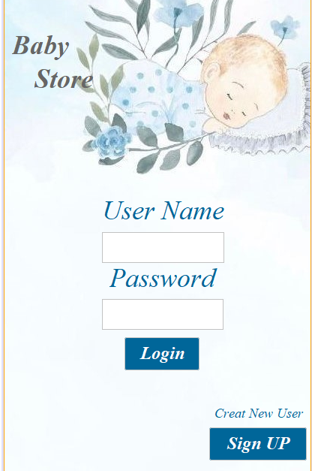

Sign Up Interface :

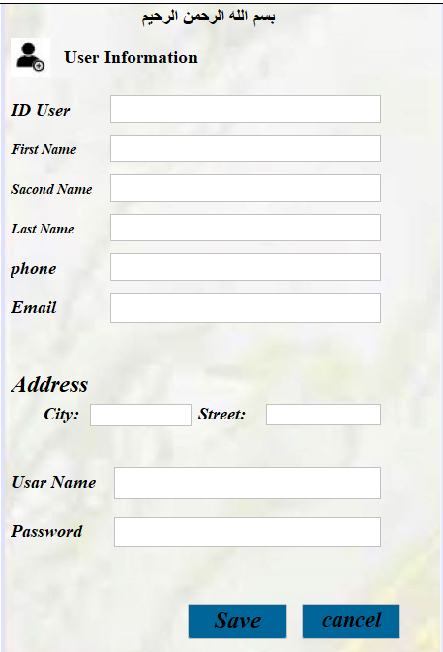

Manager Interface :

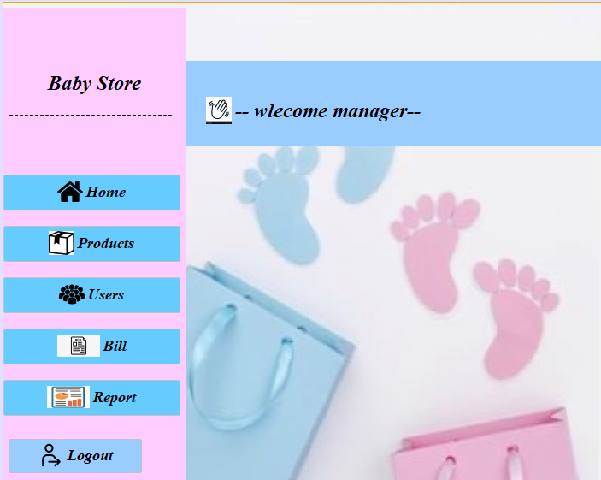

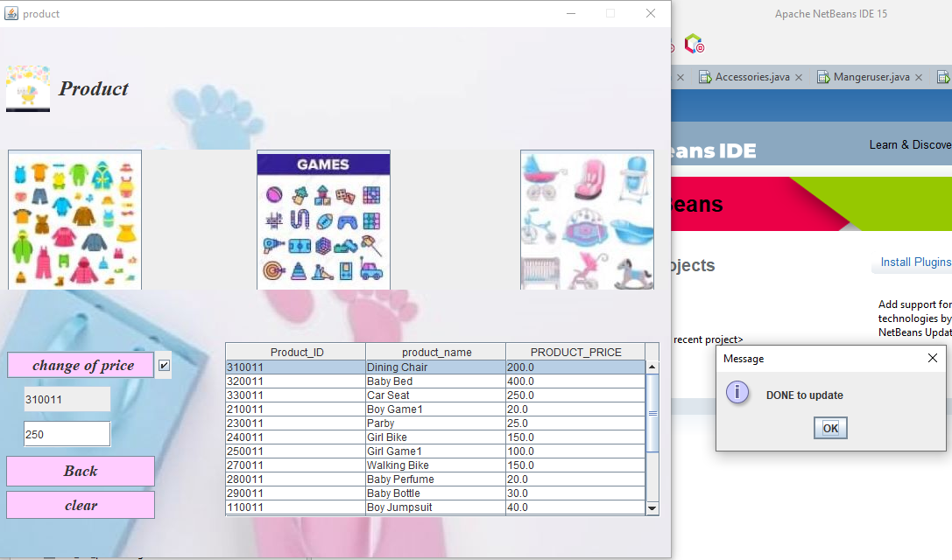

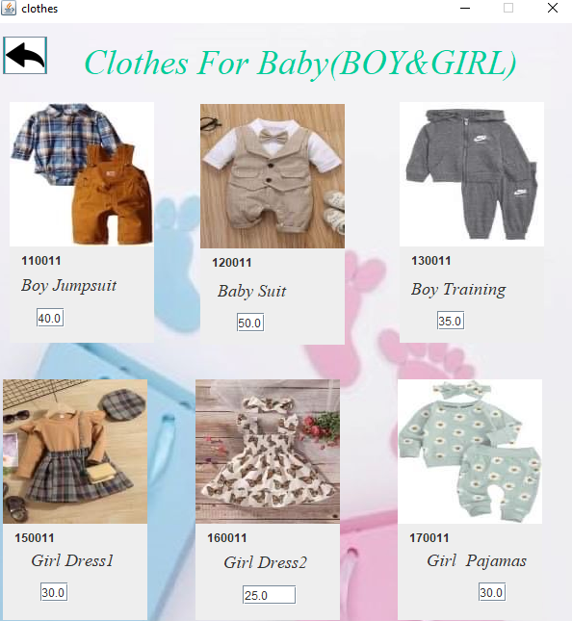

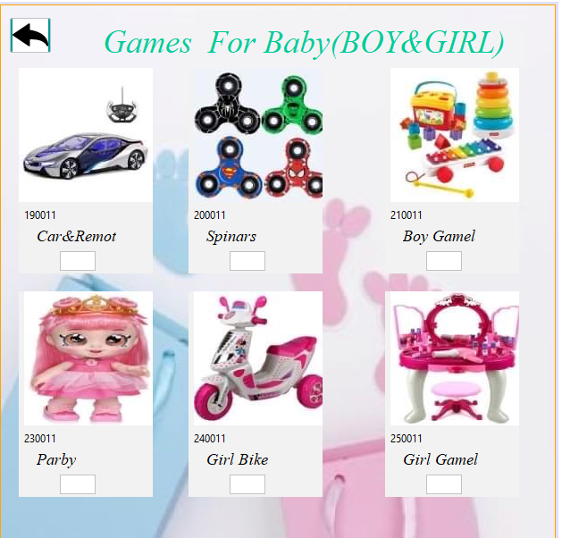

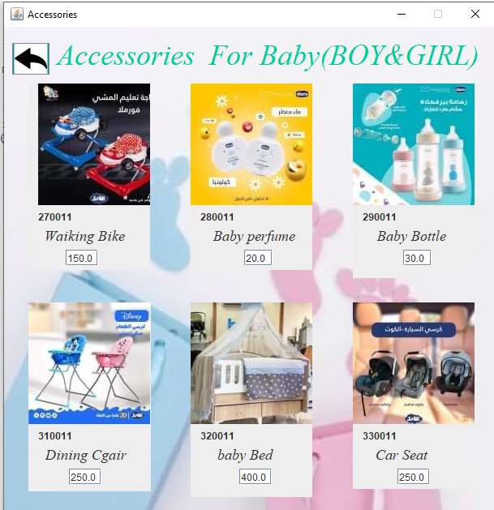

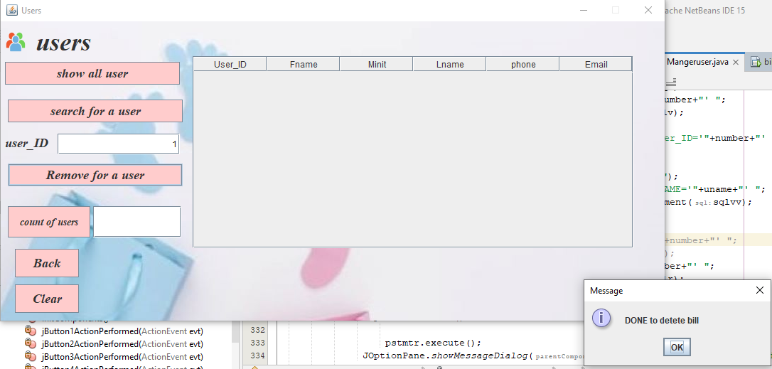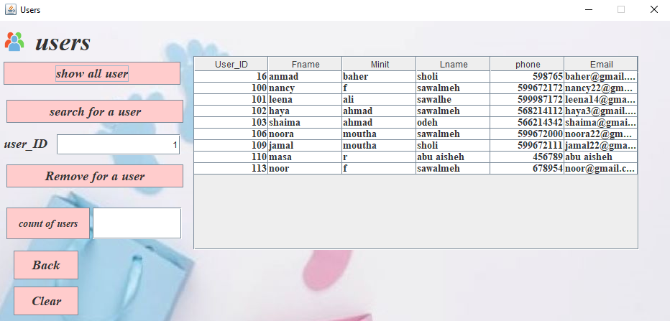

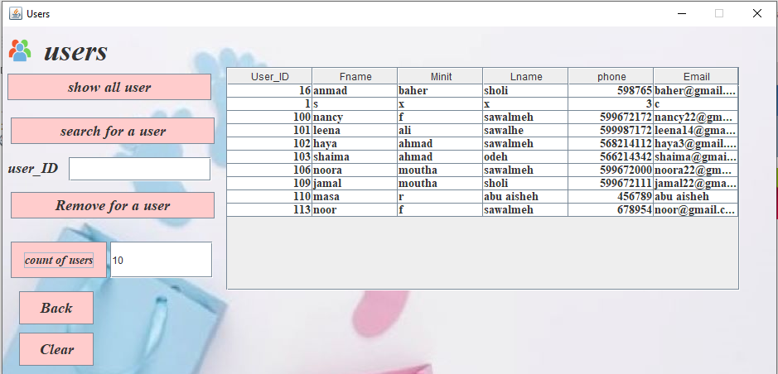

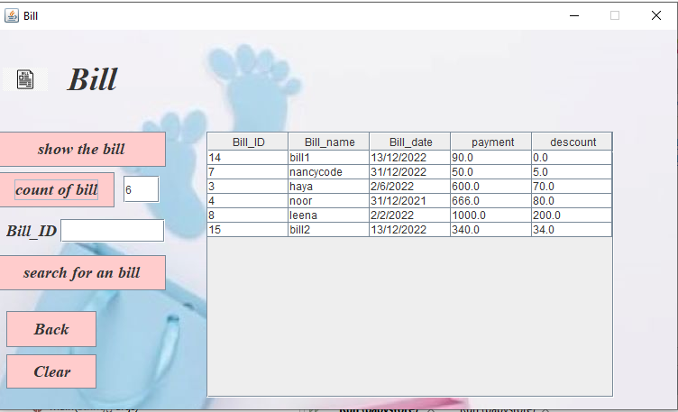

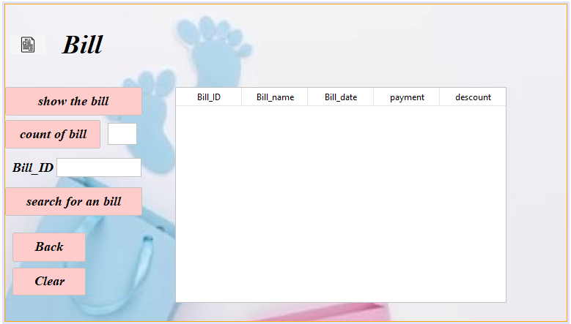

User Interface :

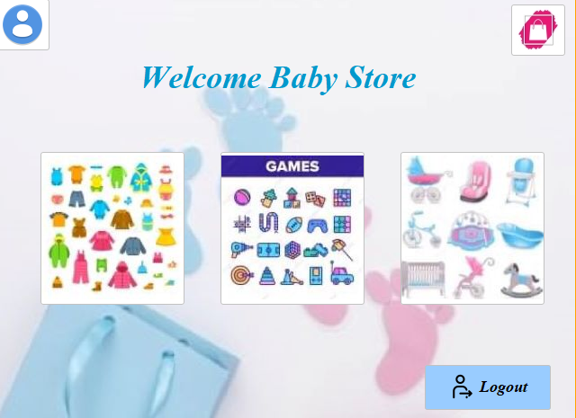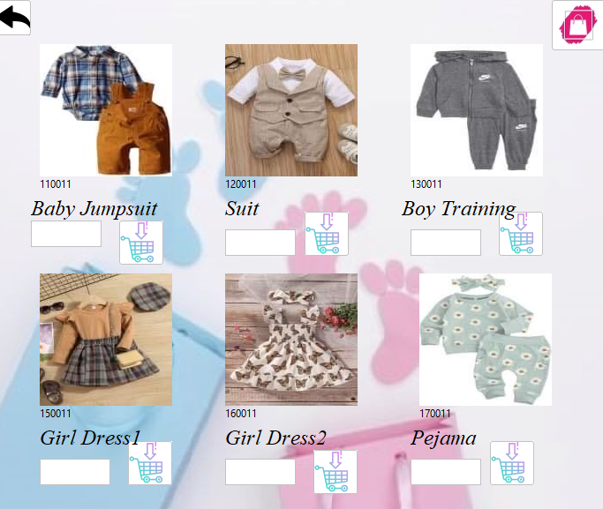

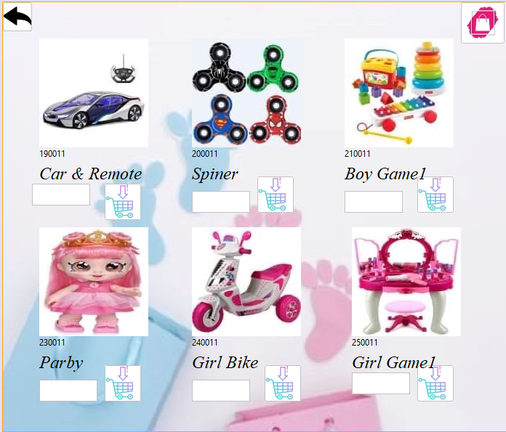

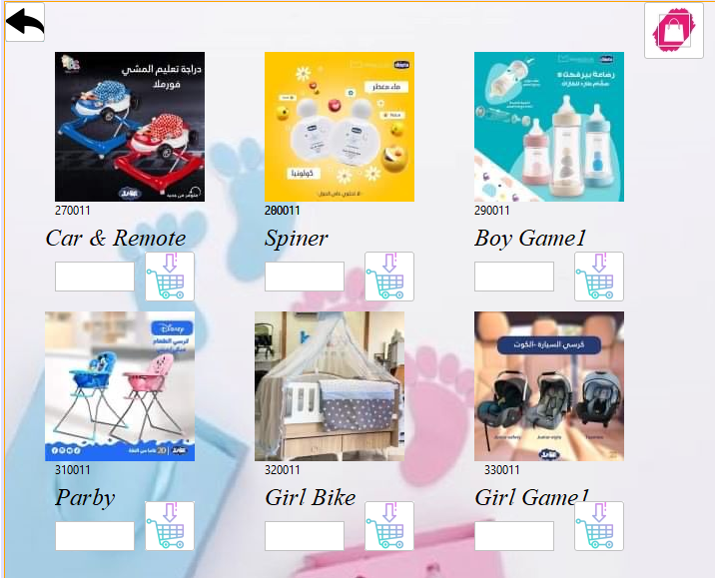

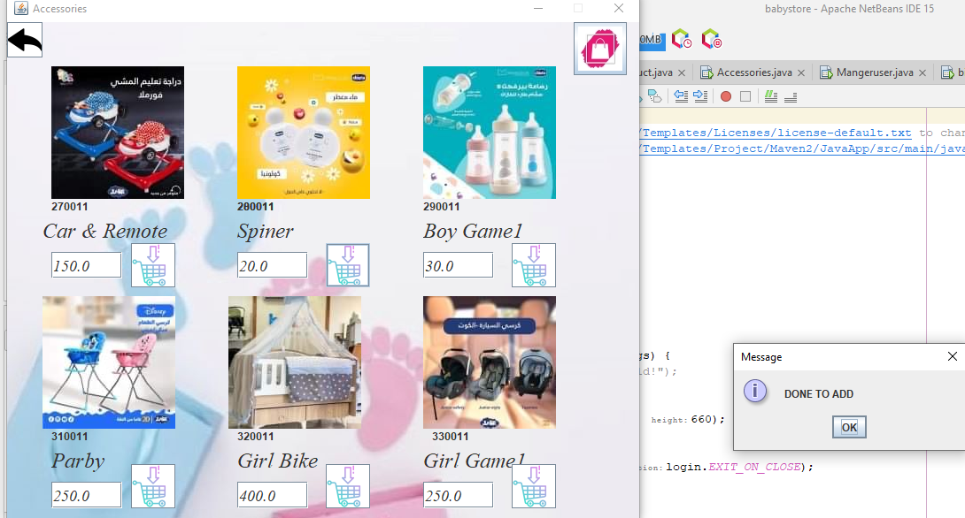

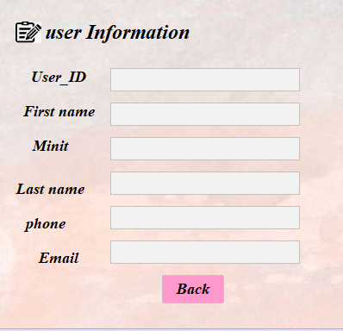

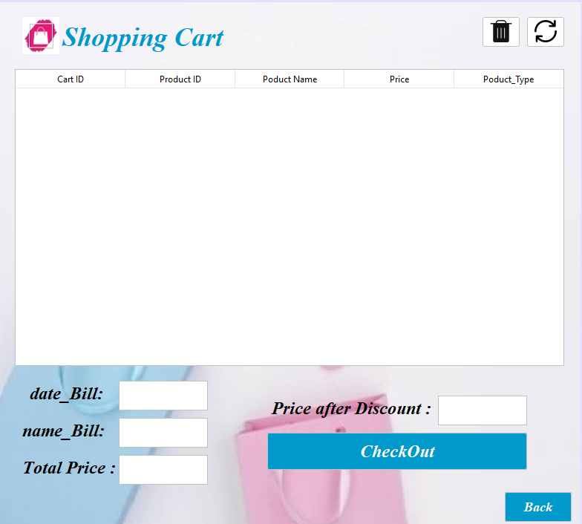

**Jasper Report**

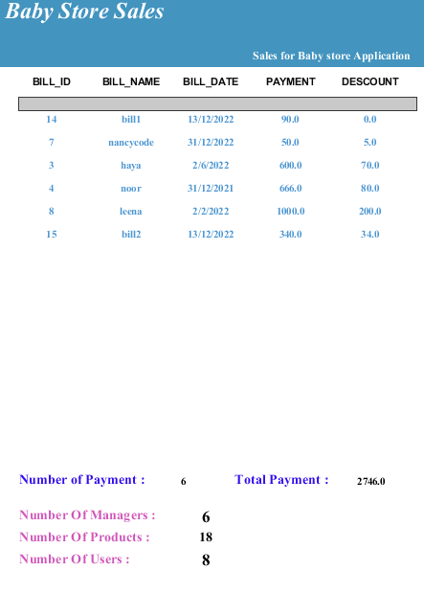

**Tools References**

* Database course by Dr.Syfyan Samara.
* JasperReports.
* SQL Developer.
* Java.
* Jdk.
* Jdbc 11.
* [Stack overflow](https://stackoverflow.com/).
* [SQL statement](https://drive.google.com/file/d/1kINXG14g5w6cjyRqmB53DuohcZBTSpBK/view?usp=sharing).
* [Libraries](https://drive.google.com/file/d/1lpohoYCxQI4tDRy9yH6yHkPjO9OU7sNz/view).

**Discussion and Conclusion:**

After we worked on building a database for this semester, we learned a lot about how to use the database to solve issues such as the baby store we worked on, while we were working on the project, we learned to connect the database using a graphical user interface(GUI). Our project meets the needs of the mother in purchasing everything that the child needs so that the mother can buy the products she needs by adding to the wallet easily, so that the product she chose is searched and made sure of its existence through the database with limited access to security, only the administrator can access everything And change the prices and add new users or add new products.